**Exercise 2 : GIT-HOL**

# Step 1: Create Files to Ignore

1. Create a .log file  
 Command: echo “This is a log file”> test.log

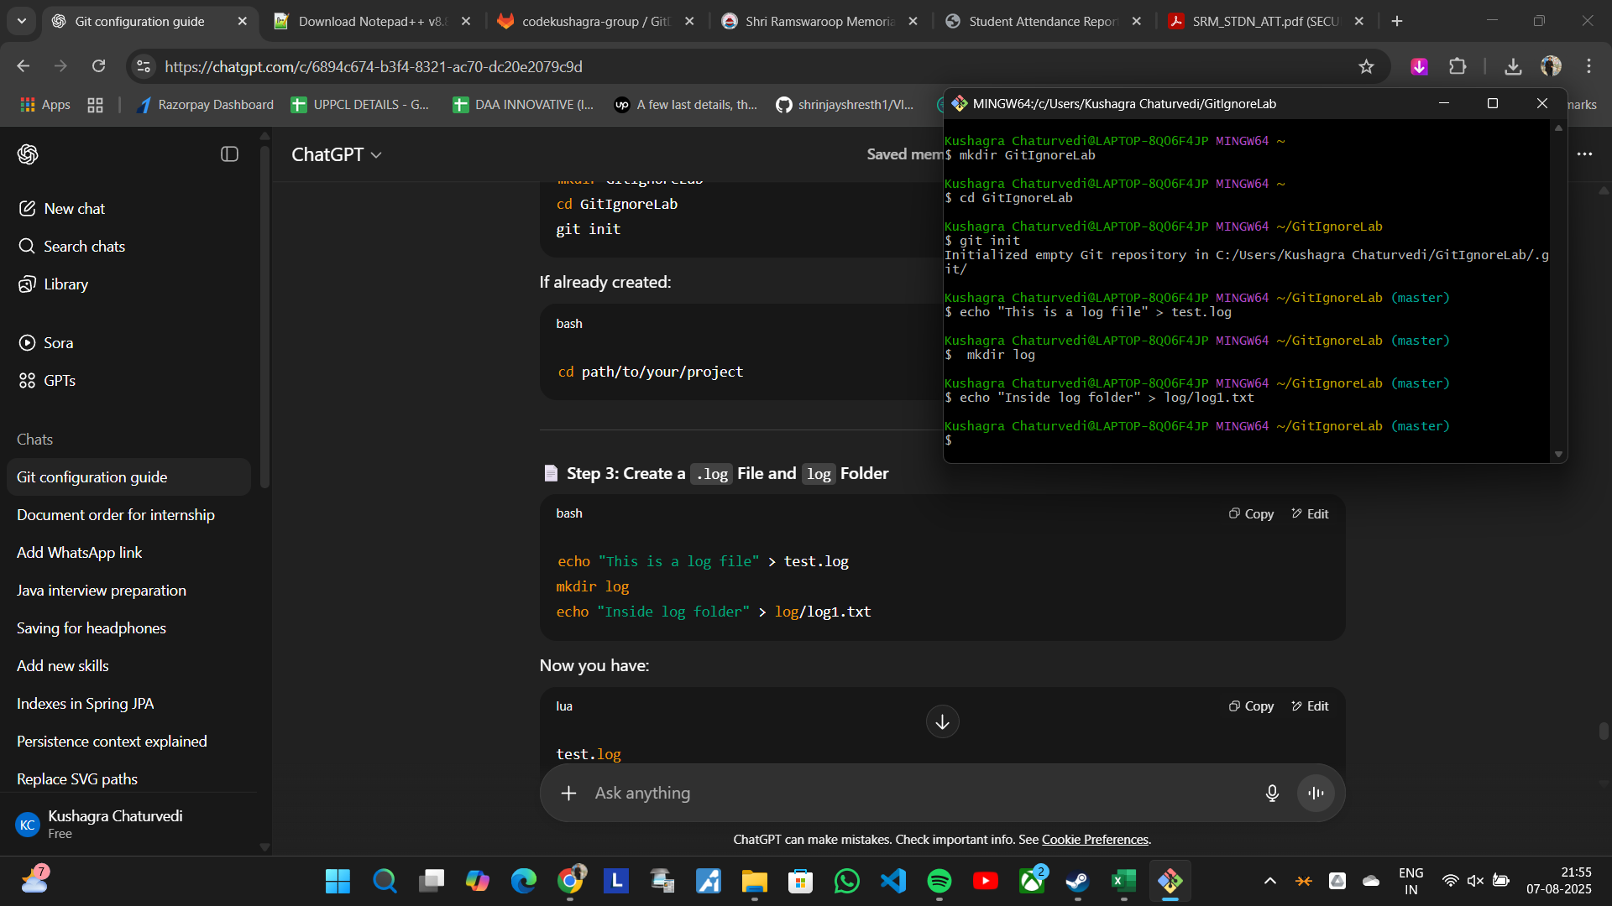

# Step 2: Create and Edit .gitignore File

1. Create a .gitignore file if not already present  
    Command: touch .gitignore
2. Open the file in Notepad and add gitignore rules

Command: notepad++ .gitignore

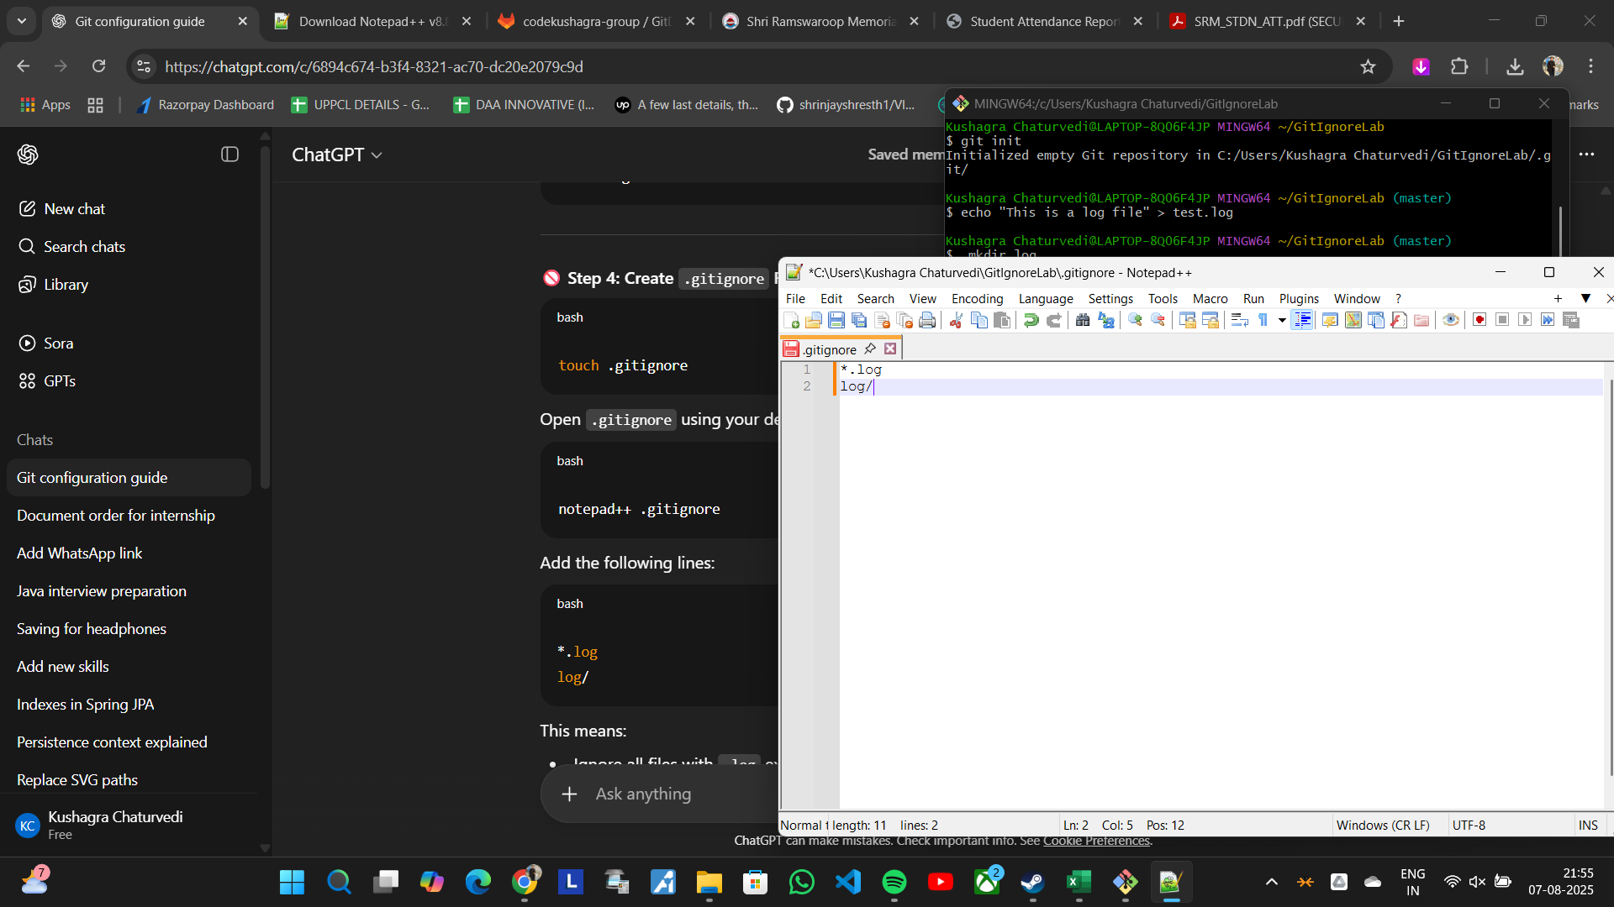

# Step 3: Verify Git Status

1. Check with files Git is tracking

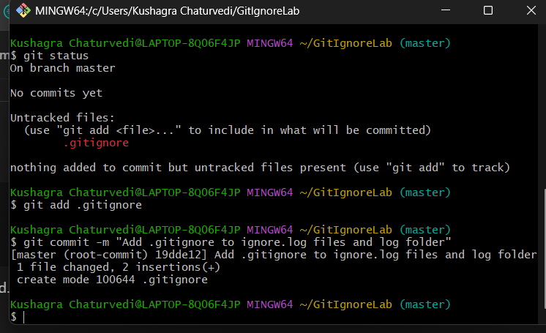Command: git status

# Step 4: Commit the .gitignore File

1. Add ,gitignore to staging

Command: git add .gitignore